EXPERIMENT 2

AIM :
Characteristics Study of Side Band Power and Frequencies in AM using MATLAB

SOFTWARE REQUIRED:
MATLAB Simulink

PROGRAM:

Clc; clear; close all;

Ac=5; m=0.5; fc=5000; fm=500;
T=0:1e-5:8e-3;

Msg=cos(2*pi*fm*t);
Car=Ac*cos(2*pi*fc*t);
Am=Ac*(1+m*msg).*cos(2*pi*fc*t);
Demod=m*msg;

Subplot(2,3,1);
Plot(t,msg); title(‘1. Message Signal (Sine)’);
Xlabel(‘Time (s)’); ylabel(‘Amplitude’); grid on;

Subplot(2,3,2);
Plot(t,car); title(‘2. Carrier Signal’);
Xlabel(‘Time (s)’); ylabel(‘Amplitude’); grid on;

Subplot(2,3,3);
Plot(t,am); title(‘3. AM Modulated Signal’);
Xlabel(‘Time (s)’); ylabel(‘Amplitude’); grid on;

Subplot(2,3,4);
Plot(t,demod); title(‘4. Demodulated Signal’);
Xlabel(‘Time (s)’); ylabel(‘Amplitude’); grid on;

Subplot(2,3,5);
Stem([fc-fm fc fc+fm],[m*Ac/2 Ac m*Ac/2]);
Title(‘5. Sideband Frequencies (USB & LSB)’);
Xlabel(‘Frequency (Hz)’); ylabel(‘Magnitude’); grid on;

Pc=Ac^2/2;
Psb=m^2*Pc/4;

Subplot(2,3,6);
Bar([Pc Psb Psb]);
Set(gca,’XTickLabel’,{‘Carrier’,’USB’,’LSB’});
Title(‘6. Sideband Power’);
Ylabel(‘Power (W)’); grid on;

OUTPUT:
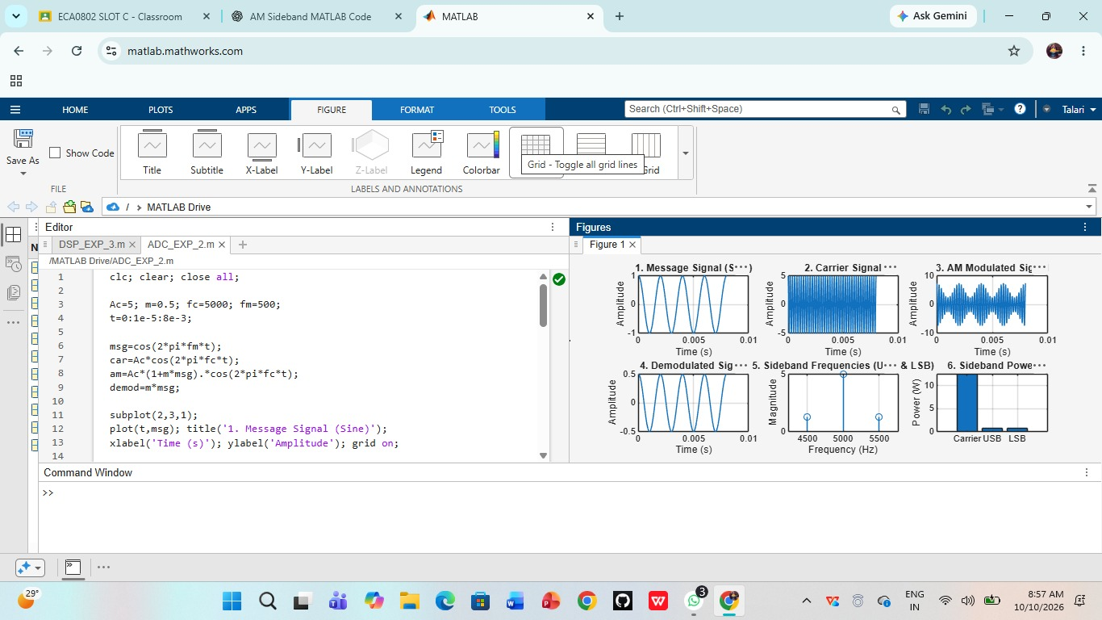

RESULT:

Thus, the characteristics of sideband frequencies and powers in AM were successfully studied using MATLAB.

